(Approx. 524 words)

Product Review: Digitz® Wireless EZmouse
By David Kazmer, Member, SCV Computer Club, California
April 2012 issue of the DATALINE
www.scvpcg.org
scvcomputerclub (at) gmail.com

Many years ago I got my first notebook PC and found out about all the gadgets it would take to be prepared to use it at any location. There were so many cables that the notebook case almost wouldn’t fit under an airplane seat. Since then, the new technologies that emerged, especially wireless, have taken a lot of the bulk out of the case. One of the remaining bulky items was the mouse, until I discovered the wireless Digitz EZmouse.

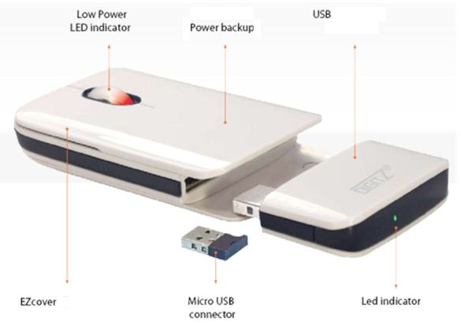
The first attraction was the flat, slim design, perfect for my notebook case. It is a small rectangular shape just 4” long by 2.1” wide, by .7” thick and weighs just .132 lbs, but that is just the tip of the iceberg. It is very comfortable to use, as you don’t have to arch your hand as with other mice. The shape fits under my hand very nicely, and the two long skids on the bottom glide very smoothly on just about any surface. There are the standard two buttons and scroll wheel, plus pressing down on the scroll wheel is the third button.

One of the amazing features is that it does not require any conventional batteries! The unit contains two lithium-ion polymer batteries, one internal and one attached through a USB connector. The external battery, about 1.25” by 2.25”, fits into the rear of the mouse and detaches for charging from any PC USB port. A red LED by the scroll wheel will blink when the external battery has about 15 minutes left. A complete charge would take about two hours and will operate the mouse for about five to six weeks of normal use. While the external battery is detached and charging, the internal battery will keep the mouse operational for up to three days. To facilitate possible charging access space problems, the USB connector on the external battery is attached by a swivel, and there is an LED at the back of the battery to indicate the progression of the charging. Life expectancy of the batteries, based on normal use, is about eight years! This innovation is impressive.

Stored in the mouse is the wireless 2.4G nano-receiver which plugs into any computer USB port. Also, if the mouse is not used for about 20 minutes it will go into a sleep mode to save the battery; just click the mouse to wake it up. The optical sensor is 1600 DPI for high accuracy. A felt carrying bag is included. The mouse is both PC and MAC plug-and-play compatible.

Ready for the icing on the cake? The top cover can be replaced by one of your own design by ordering it from Digitz and sending them a JPG picture of your choice! Check www.digitzgroup.com for more details and an informative video. If the display does not appear in English, just click on the small American Flag icon.

SCV Computer Club Rating (0-5, 5 being best)


Digitz EZMouse
www.digitzgroup.com / www.ezmouse.com
info@digitzgroup.com
$49.95 (Free shipping – USA and Canada)

